Batch size 128 / 128 , Learning rate 0.01

#0 Loss: 1.0522 Acc: 68.2554% Time: 533.2898s

[Test Phase] Loss: 0.5327 Acc: 85.6667% Top3 Acc: 97.3333% Time: 536.8782s

#1 Loss: 0.5080 Acc: 84.5925% Time: 1065.7593s

[Test Phase] Loss: 0.9080 Acc: 80.0000% Top3 Acc: 94.3333% Time: 1069.7542s

#2 Loss: 0.3858 Acc: 88.2265% Time: 1597.5730s

[Test Phase] Loss: 0.6386 Acc: 87.3333% Top3 Acc: 96.0000% Time: 1601.5472s

#3 Loss: 0.2553 Acc: 92.1229% Time: 2129.7075s

[Test Phase] Loss: 0.7427 Acc: 84.3333% Top3 Acc: 95.3333% Time: 2133.6334s

#4 Loss: 0.1838 Acc: 94.3580% Time: 2662.1128s

[Test Phase] Loss: 0.6674 Acc: 84.3333% Top3 Acc: 97.0000% Time: 2665.1467s

#5 Loss: 0.1590 Acc: 95.1203% Time: 3182.2540s

[Test Phase] Loss: 0.6122 Acc: 87.0000% Top3 Acc: 95.3333% Time: 3185.4361s

#6 Loss: 0.1232 Acc: 96.2641% Time: 3702.6235s

[Test Phase] Loss: 0.8543 Acc: 82.6667% Top3 Acc: 97.0000% Time: 3705.8339s

#7 Loss: 0.1226 Acc: 96.2214% Time: 4222.3396s

[Test Phase] Loss: 0.7776 Acc: 85.0000% Top3 Acc: 97.6667% Time: 4225.5524s

#8 Loss: 0.1143 Acc: 96.4722% Time: 4739.4885s

[Test Phase] Loss: 0.9873 Acc: 81.0000% Top3 Acc: 95.0000% Time: 4742.6861s

#9 Loss: 0.1789 Acc: 94.6277% Time: 5259.1759s

[Test Phase] Loss: 0.7669 Acc: 86.0000% Top3 Acc: 96.0000% Time: 5262.6466s

#10 Loss: 0.1046 Acc: 96.8103% Time: 5779.4670s

[Test Phase] Loss: 0.7912 Acc: 84.0000% Top3 Acc: 96.6667% Time: 5782.9404s

#11 Loss: 0.0856 Acc: 97.4225% Time: 6299.0752s

[Test Phase] Loss: 1.1117 Acc: 82.3333% Top3 Acc: 94.3333% Time: 6302.4351s

#12 Loss: 0.0906 Acc: 97.2937% Time: 6819.4987s

[Test Phase] Loss: 0.7049 Acc: 87.6667% Top3 Acc: 97.0000% Time: 6822.8775s

#13 Loss: 0.0679 Acc: 97.9822% Time: 7340.1589s

[Test Phase] Loss: 0.8456 Acc: 84.6667% Top3 Acc: 96.3333% Time: 7343.2894s

#14 Loss: 0.0914 Acc: 97.3035% Time: 7861.3447s

[Test Phase] Loss: 0.9051 Acc: 86.6667% Top3 Acc: 95.3333% Time: 7864.9539s

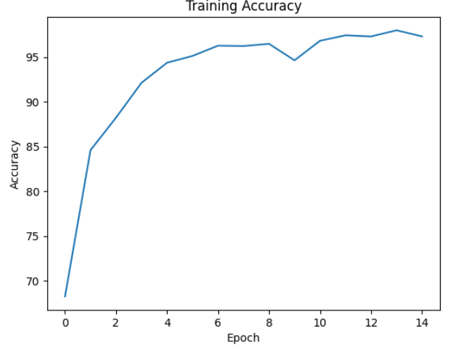

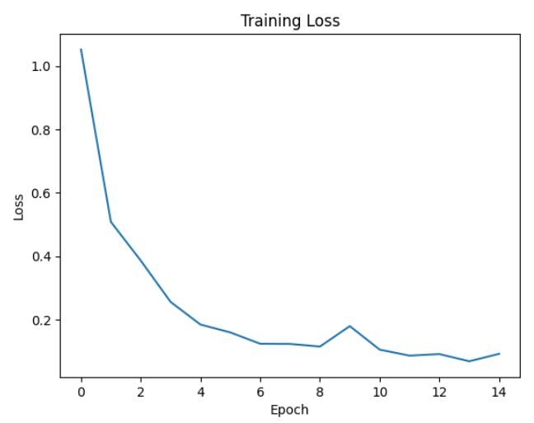

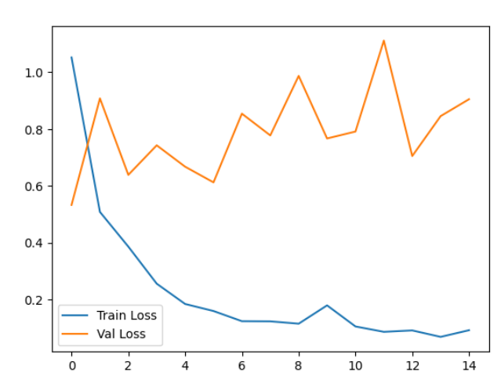

Batch size 32 / 32 , Learning rate 0.001

#0 Loss: 1.1729 Acc: 65.3056% Time: 591.2568s

[Test Phase] Loss: 0.3851 Acc: 89.3333% Top3 Acc: 98.3333% Time: 593.5099s

#1 Loss: 0.5281 Acc: 84.1933% Time: 1184.1655s

[Test Phase] Loss: 0.4523 Acc: 86.3333% Top3 Acc: 97.6667% Time: 1186.2397s

#2 Loss: 0.3372 Acc: 89.8762% Time: 1776.5762s

[Test Phase] Loss: 0.5044 Acc: 86.6667% Top3 Acc: 97.6667% Time: 1778.7647s

#3 Loss: 0.2345 Acc: 93.0091% Time: 2355.9214s

[Test Phase] Loss: 0.5983 Acc: 87.0000% Top3 Acc: 97.3333% Time: 2357.7757s

#4 Loss: 0.1724 Acc: 94.8151% Time: 2931.5366s

[Test Phase] Loss: 0.5677 Acc: 86.6667% Top3 Acc: 97.0000% Time: 2933.3794s

#5 Loss: 0.1292 Acc: 96.1445% Time: 3505.9230s

[Test Phase] Loss: 0.4709 Acc: 87.3333% Top3 Acc: 97.0000% Time: 3507.8258s

#6 Loss: 0.1035 Acc: 96.8830% Time: 4078.4472s

[Test Phase] Loss: 0.4634 Acc: 88.6667% Top3 Acc: 97.0000% Time: 4080.3664s

#7 Loss: 0.0864 Acc: 97.3859% Time: 4653.8768s

[Test Phase] Loss: 0.5174 Acc: 88.3333% Top3 Acc: 97.6667% Time: 4655.9633s

#8 Loss: 0.0676 Acc: 97.9462% Time: 5229.0569s

[Test Phase] Loss: 0.5473 Acc: 86.6667% Top3 Acc: 97.3333% Time: 5231.0120s

#9 Loss: 0.0579 Acc: 98.2654% Time: 5803.7369s

[Test Phase] Loss: 0.6150 Acc: 86.6667% Top3 Acc: 96.3333% Time: 5806.1874s

#10 Loss: 0.0461 Acc: 98.6322% Time: 6380.3383s

[Test Phase] Loss: 0.5423 Acc: 86.3333% Top3 Acc: 96.6667% Time: 6382.1788s

#11 Loss: 0.0382 Acc: 98.8690% Time: 6954.5887s

[Test Phase] Loss: 0.5587 Acc: 87.3333% Top3 Acc: 97.3333% Time: 6956.6119s

#12 Loss: 0.0340 Acc: 99.0057% Time: 7533.9149s

[Test Phase] Loss: 0.5981 Acc: 88.6667% Top3 Acc: 96.6667% Time: 7535.7373s

#13 Loss: 0.0300 Acc: 99.0961% Time: 8113.7251s

[Test Phase] Loss: 0.5173 Acc: 90.0000% Top3 Acc: 97.0000% Time: 8115.8312s

#14 Loss: 0.0251 Acc: 99.2487% Time: 8693.4147s

[Test Phase] Loss: 0.5565 Acc: 89.3333% Top3 Acc: 97.3333% Time: 8695.2352s

